Y Gât, Pentre Road, St Clears, Carmarthen, SA33 4AA
07468 456077
e-mail: clerk@stclearstowncouncil.co.uk

Minutes of Ordinary Meeting of Council (FC) held on 15th September 2026 at 7.00pm at Y Gât
MEMBERS PRESENT: Cllrs S.Cox, Dr WEVJDavies, R.Davies, M.A. Jones, K.Major, J. Rees (Town Mayor), I. Thomas-Wigley, B. Thornton,
Press: 0, Members of the Public: 0, County Councillors: 2

- Apologies. RESOLVED to approve apologies as received from Cllr R.G.Edwards.

- Declarations of interest. RBL – Cllr J.Rees and B.Thornton.

- To approve the minutes of the Full Council meeting held on 21st July 2026. RESOLVED to approve the minutes of the Full Council meeting held on 21st July 2026 as a true record of proceedings.

- To approve the minutes of the special meeting held on 29th July 2026. RESOLVED to approve the minutes of the Full Council meeting held on 29th July 2026 as a true record of proceedings.

- Matters Arising.
The following updates were noted:
- 2026.040 – School requested alternative non-parent nomination for Ysgol Griffith Jones Board of Governors. Parent applications (x3) will be opened during the autumn term. Noted: Council agreed to continue with original proposal.
- 2026.048 – Updating of the Mayoral Board. The original artist has retired; Malcolm Murphy has been sought and will complete the work by end of November 2026.
- 2026.050 – Defibrillator at Y Gât. Awaiting planning response and further information from Tenby First Responders.
- 2026.052 – New bench installed at Maes y Bryn by the Council contractor. The Men’s Shed is repairing the remaining benches as approved.
- 2026.053 – Approved skate park repairs completed.
- 2026.055 – Remembrance Sunday Road Closure application submitted to CCC.

- To review Members Interest forms prior to publication. DEFERRED.

Members agreed to note updates from the County Councillors in attendance, Cllrs C. Jones and P. Hughes. Resurfacing along Pentre Road, the yellow lines and parking bays to be reinstated by the end of October
- Town Council sought an update on CCC’s asset review process and assistance with a reply in respect of Christmas light connections on designated lighting columns.
- Concerns raised as transport being blocked due to vehicles being parked along key roads within the town.
- Request for card-payment facility at toilet in carpark.
- Safer routes to schools’ scheme (Place & Sustainability dept.)– consideration to include, pelican crossing, footpaths, lights along Peillac way footpath.
- Consider ideas for Community benefit funding and future S106.
- Y Gât – assistance with actioning works to the fabric of the building, e.g. flooring, guttering etc. Information and correspondence to be forwarded to County Councillors for consideration.
- Community Flood event – John Burns Centre, Kidwelly – Thursday 17/09/26 at 2pm and 5pm.

- To receive the Clerk’s Report.

- Carmarthenshire County Council

(i). Planning/Licensing.

PL/11133  20/07/2026 | Link | Modification of Section 106 Agreement. Application to modify planning obligation secured under planning permission PL/03374 for residential development | Land to the west of High Street, St Clears, Carmarthen | Under Consultation | Consultation Period
PL/11148  21/07/2026 | Link | Lawful development: Existing use. Lawful Development Certificate - existing use - single dwelling house | Trefenty Farm, St Clears, Carmarthen, SA33 4NG | In Review | Awaiting Decision
PL/11205  11/08/2026 | PL/11205 | Full planning permission Proposed 1 bay extension and lean-to plus changed to fenestration since construction | 2-5 Blewgyd, St Clears, Carmarthen, SA33 4LX | Dyddiad Dechrau Ymgynghori: 11/08/2026 | Dyddiad Gorffen Ymgynghori: 01/09/2026
PL/11177  12/08/26 | PL/11177 | Variation of Condition 1 on PL/00736 (Extend period for submission of Reserved Matters by a further three years) | Llys Newydd Gardde Fields, High Street, St Clears, Carmarthen, SA33 4DY | Dyddiad Dechrau Ymgynghori: 12/08/2026 | Dyddiad Gorffen Ymgynghori: 02/09/2026
PL/11230  11/08/2026 | PL/11230 | Approval of details reserved by a condition. Discharge of Conditions 3 and 11 on PL/09771 (Written Scheme of Investigation and Travel Plan) | Land north of Heol Goi, St Clears, SA33 4DY | Under Consultation | Consultation Period

ii) Code of Conduct PowerPoint and information – circulated to members

iii) Ysgol Griffith Jones Governing Body representative. RESOLVED to continue with original nomination following review of School Governing Body Governance Document.

iv) Consultation Proposal to amend the Welsh language provision at Ysgol Griffith Jones.
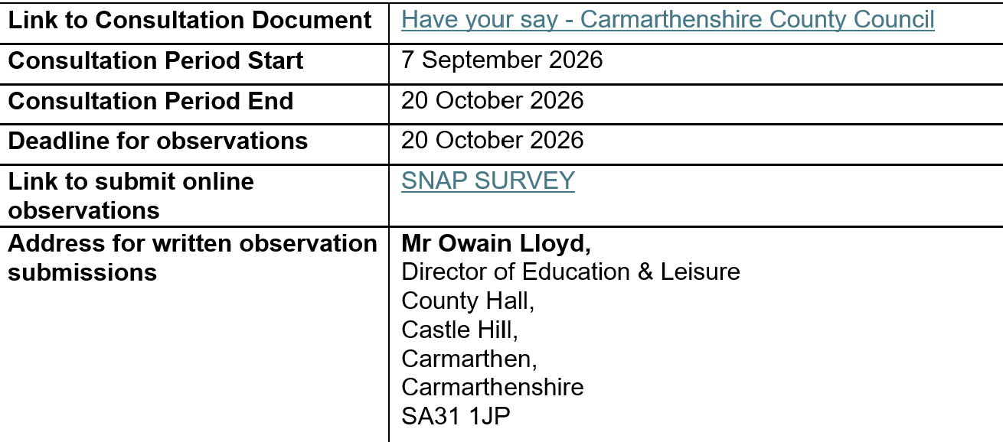
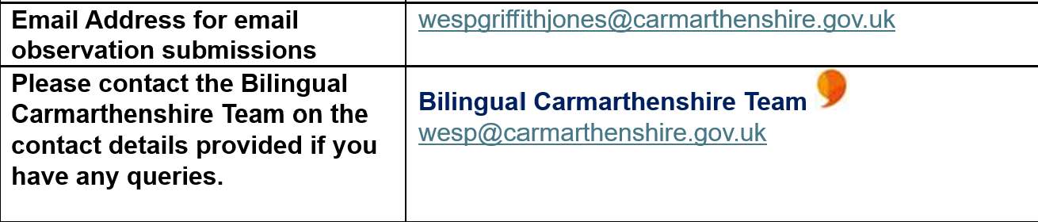

v) Rewilding Britain – Rewilding Innovation Fund
This fund aims to foster new and ambitious community rewilding projects, and to remove barriers to rewilding projects within Britain, whether they’re at the early planning stages or want to move a project one step wilder. Funding will be awarded to projects with potential for the highest impact for people and nature. https://www.rewildingbritain.org.uk/how-to-rewild/funding-for-rewilding/rewilding-innovation-fund

v) National Garden Scheme – Community Gardens Grants
The funding is for gardening projects carried out within local communities in England, Wales or Northern Ireland.
The scheme is committed to:
- Sustainability in gardening; so, proposals need to demonstrate that they will be using sustainable gardening methods – for instance being as far as possible peat-free.
Celebrating biodiversity; whilst not essential, projects that can demonstrate support to biodiversity/wildlife are positively encouraged. https://ngs.org.uk/who-we-are/community-garden-grants/

vi) Environment Business Support Hub W&E – Ace Playgrounds noted social media correspondence regarding Juvenile Sports Association Lower St Clears Playpark www.ace-playgrounds.co.uk

- One Voice Wales / SLCC
- The Local Government Association (LGA), acting on behalf of the National Joint Council (NJC) for Local Government Services, has announced that agreement has been reached on the 2026 pay award for local government employees. The settlement provides for a 3.3% increase in pay rates and allowances with effect from 1 April 2026. The agreed pay award covers the period from 1 April 2026 to 31 March 2027, and employers are being encouraged to implement the increase as quickly as possible.

- SLCC – Catherine Lloyd-Jenkins, St Clears Town Council Clerk has successfully completed the Principles of Internal Auditing Local Councils (PIALC) certificate.

- Finance
- Audit notice period concluded and documents submitted to Audit Wales after the nominated date.

- Anti-Social Behaviour Hate Crime
This session will give you a knowledge of this and what support and reporting options are available if you or someone you know or support is a victim of ASB hate crime.
Antisocial Behaviour related hate:
What is Antisocial Behaviour?
The impacts of antisocial behaviour related hate
Services available for those impacted
28/09/2026 1pm
https://www.eventbrite.co.uk/e/1993459184082
17/11/2026 10am
https://www.eventbrite.co.uk/e/1993459068737
14/12/2026 1pm
https://www.eventbrite.co.uk/e/1993458830023

Understanding Mate Crime
A short introduction to mate crime and its impacts.
Held virtually, this FREE short awareness session will introduce you to 'Mate Crime' - what it is, who it impacts, how it connects to Hate Crime and how we can all play a part to spot it and act.
16/09/2026 10am (Alzheimer’s Day)
https://www.eventbrite.co.uk/e/1993458478973
04/11/2026 10am (Disability History Month)
https://www.eventbrite.co.uk/e/1993458410769
01/12/2026 10am (International Day of Person with Disability)
https://www.eventbrite.co.uk/e/1993458343568
Understanding Hate Crime
Join Victim Support's Hate Crime Training & Engagement Officers for a 2-hour session and understand in more depth the challenges facing these groups when experiencing and reporting hate crime. And importantly, how YOU can help.
Suitable for those living or working in Wales.
02/09/2026 9am
https://www.eventbrite.co.uk/e/1993459224202
13/10/2026 1pm (National Hate Crime Awareness Week)
https://www.eventbrite.co.uk/e/1993459242256
07/12/2026 1pm
https://www.eventbrite.co.uk/e/1993459257301
Online Hate
The sessions seeks to debunk myths around how platforms manage hate, explore the impact of online harms such as hate, and to share practical advice on how to tackle online hate.
07/09/2026 1pm
https://www.eventbrite.co.uk/e/1993457850092
04/11/2026 12pm
https://www.eventbrite.co.uk/e/1993458183088
08/12/2026 12pm
https://www.eventbrite.co.uk/e/1993458159016
Young People & Modern Hate in Wales (Anti-Bullying Week)
Hate can impact on people and communities in profound ways. For children and young people, hateful experiences can be impactful and long lasting, and the barriers to seeking support even more complex.
10/11/2026 1pm
https://www.eventbrite.co.uk/e/1993459306448
It Starts With Us
Hate happens and it’s clear that it’s hurtful for communities in Wales.
Our It Starts With Us workshop explores what it means to be an ally and an active bystander, looking at safe interventions and acts that we can all undertake.
15/09/2026 10am
https://www.eventbrite.co.uk/e/1993458478973
21/10/2026 1pm (Pro-nouns Day)
https://www.eventbrite.co.uk/e/1993458579273
30/11/2026 1pm
https://www.eventbrite.co.uk/e/1993458657507

- Other
- British Telecom – adopt a kiosk. Confirmed that engineer is awaiting training prior to completion and that once this is completed the Town Council will be informed.
- Police and Crime Commissioner, Dafydd Llywelyn is launching his next Community Scrutiny Panel in Llanelli and is inviting members of the public to get involved.
The panel will take place in Llanelli on:
📅 9 September 2026
🕓16:00 – 19:00hrs
Deadline for applications: 24 August 2026
Find out more and sign up: https://forms.cloud.microsoft/e/yPK5x5iFyc?origin=lprLink


- Hywel Dda University Health Board Proposed Changes to Maternity Services is seeking feedback on the proposed ending of its Service Level Agreement (SLA) with Swansea Bay University Health Board in December 2026.
The current agreement allows women living in Carmarthenshire, Ceredigion and Pembrokeshire who choose to give birth at Singleton Hospital to attend antenatal clinics and ultrasound scans at Prince Philip Hospital. From December 2026, if the woman chooses Singleton Hospital:
Obstetric-led antenatal appointments will take place at Singleton Hospital.
Ultrasound scans, for both obstetric-led and midwifery-led care, will take place at Singleton Hospital.
Women choosing to give birth within Hywel Dda services will see no change; antenatal clinics and ultrasound scans will continue at Prince Philip Hospital.
Community midwifery care will remain unchanged and will continue to be provided locally.
The health boards state that ending the agreement will help address differences in clinical guidelines, policies and governance arrangements, with the aim of providing a safer, more coherent and sustainable pathway, alongside improved clinical governance, continuity of care and accountability.
Public consultation: 17 August – 28 September 2026.
Ways to provide feedback:
Online survey: Hywel Dda Have Your Say
Request a paper survey by emailing Hyweldda.Engagement@wales.nhs.uk and return via Freepost HYWEL DDA HEALTH BOARD.
Telephone the Hywel Dda Communication Hub on 0300 303 8322 (option 5).
Attend an online engagement session on Monday 7 September 2026, 6pm–7pm, to hear about the proposed changes and provide feedback.

- Dŵr Cymru. Forthcoming improvement works in Bancyfelin will involve installing an underground storage tank to help reduce storm overflow operation and protect the local environment. Works are due to start on 1 September 2026 and continue until the end of January 2027, with increased traffic expected during the initial mobilisation period. Normal
working hours will be Monday to Friday, 7:00am to 5:00pm.

- Hywel Dda Engagement - Clinical Services Plan – Stroke Services: conscientious consideration of feedback. As part of the conscientious consideration process, following consultation stakeholders are invited to help review the feedback collected during the consultation, as summarised in the draft consultation report. This feedback will inform the report that will be formally considered by the Board during their conscientious consideration process. Your perspective as a Town Council/Councillor would be greatly appreciated. Your feedback on our draft consultation report will help inform this next stage, as we move towards a decision on the future service model for stroke in Hywel Dda.
Please see the draft report on this link https://www.haveyoursay.hduhb.wales.nhs.uk/clinical-services-plan-stroke-services-conscientious-consideration-of-feedback
Feedback can be shared via survey https://www.haveyoursay.hduhb.wales.nhs.uk/embeds/projects/52104/survey-tools/60476 by 30 September 2026.
if you have any questions, please contact the Engagement Team at: hyweldda.engagement@wales.nhs.uk

- Complaint received – Council Concerns and Complaints Policy actioned. Chair and Clerk reviewed evidence in accordance with the policy and outcome reply issued.

- Correspondence -
- R. Youle Wales Online – concerns raised and request for response to series of questions on administration, salary, correspondence etc. NOTED, reply issued.
- P.Lanc – clarification on event and use of outside Y Gât. NOTED - reply issued.
- P.Lanc – clarification on Guide Hut commentary. NOTED - reply issued.
- L.Evans – statue film/documentation information. NOTED - CCC responsibility and confirmed ready for publication.
- T.Roberts – Network rail Letter re downgrading Ffynnogain railway crossing. NOTED – circulated and published on website.
- V.Wiles – Toilet facilities no card option for payment. NOTED – inform CCC
- Taylor Dyderski – parking ticket issue. NOTED
- Kris O’Kane, Narberth Town Council – staffing and salary information. NOTED - reply issued.
- Mr Ebsworth – flag flying concerns expressed. NOTED
- K.Jones – regeneration and engagement job proposal.
- L.Ebsdon – condition of play park & membership of Council. NOTED – reply issued.
- P.Lanc – follow-up on Guide hut commentary – NOTED – reply issued
- P.Lanc – specific correspondence regarding Guides Hut and asbestos report – NOTED – holding reply issued
- P.Lanc – further correspondence regarding Guides Hut and asbestos report - NOTED – reply issued
- P.Lanc – request to meet Cllr Mair Jones. NOTED – reply issued
- P.Lanc – further request for clarification on publication of minutes - NOTED – reply issued
- P.Lanc - further information on Council policy and administration - NOTED – reply issued
- P.Lanc – request to review finances - NOTED – reply issued
- G.Jones - Owain Glyndŵr Day to be celebrated on Wednesday, 16 September 2026. Organisations encouraged to promote his name and story on the day, with many CADW sites expected to fly the Glyndŵr flag. Details of planned events can be found here:https://www.owainglyndwr.cymru/forthcoming_events.html. NOTED
- R.Watkins RBL - Wreath for Remembrance Event. RESOLVED to approve St Clears Town Council wreath for the Remembrance event as in previous years.

- To approve a Policy of the Honorary Freedom of the Town. RESOLVED to approve the Policy of the Honorary Freedom of the Town.

- To consider future maintenance arrangement for watering planters at Pwll Trap and Bancyfelin, including the need for volunteers and vegetation cutback along Peillac Way. Members considered different options. Members wished to thank Jonathan Williams, contractor for his work and diligence in watering the planters and hanging baskets during the extreme heat during the summer. RESOLVED to continue with the Council contractor and those currently assisting.

NOTED. Peillac way footpath is the responsibility of Carmarthenshire County Council and the issue of the overgrown hedge has been resolved.

To consider the possibility of a drinking water fountain near the car park. RESOLVED to contact Welsh Water.

- To receive updates to Bancyfelin Play Park lease. The latest correspondence received was NOTED. DEFERRED

- To receive an update following the removal of the Christmas tree at Bancyfelin. Due to works to the access and replacement of the school fencing, the Christmas tree was inadvertently cut down and removed. CCC has given reassurance that a Christmas tree will be replanted as soon as is practical and another to decorate for this year’s Christmas event.

- To approve the schedules of payments for August and September 2026. RESOLVED to approve the schedule of payments for August and September 2026.

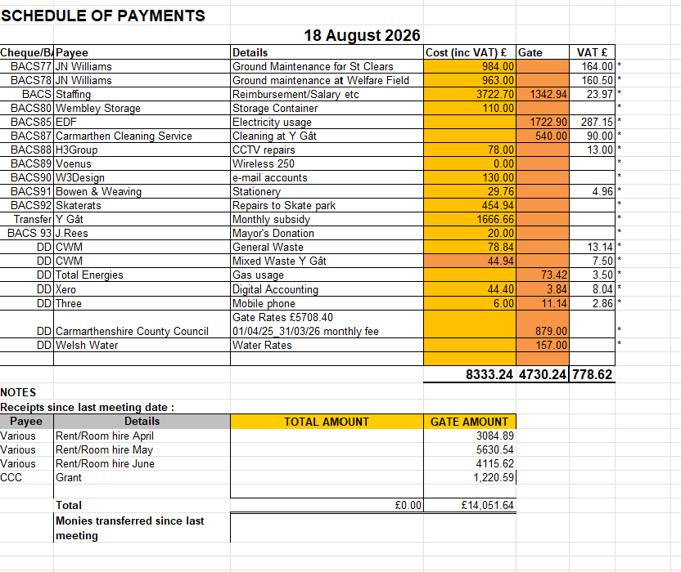
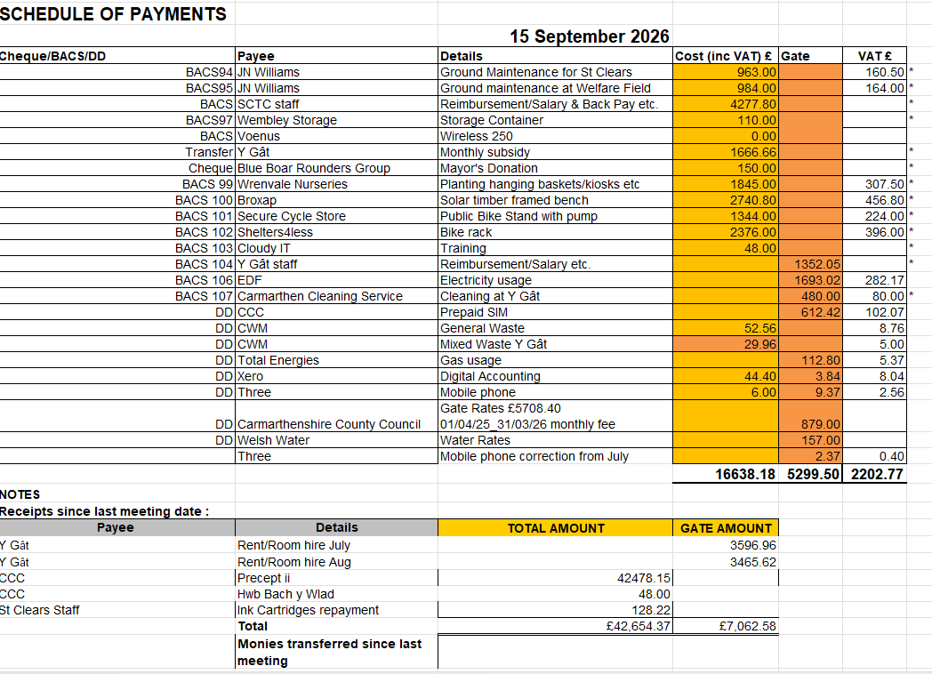

- To note external Audit Report. DEFERRED. Report not yet received.

- To consider replacement printer for the Council. Council considered the various options of leasing or direct purchase. RESOLVED to permit the clerk to purchase the best value for money option for the Town Council to complete its functions and admin work.

- To consider objectives for the year ahead. DEFERRED. Members to consider objectives to consider during the next monthly meeting of Council.

- To consider the Play park and Skate park reports. NOTED.

- To receive updates on grant applications. NOTED.
- Rural Market Town Vibrancy Fund – Application successful. Items as noted on application ordered. Council contractor contacted to confirm assembly/fitting. Completion date agreed.
- Carmarthenshire Renewable Energy Grant – Tender document drafted and submitted to CCC for approval. Contractor names sought in preparation.
- Open Spaces grant – Application successful. Design a park project sent to local school for design ideas. Updated Community questionnaire submitted on Council website and Facebook (71 replies to date). Tender document drafted and submitted to CCC for approval before publication. Contractor names sought in preparation.

PROPOSE STANDING ORDERS

- To consider the vacant seats on the Council. NOTED. No applications to consider.

- To receive reports from representatives on meeting of outside bodies, seminars etc. NONE.

- To receive the Town Mayor’s Report on civic events, engagements etc.
- 28th July – attended. The newly established women’s St Clears Board Force Rounders Team invited me to attend a training session, where I was delighted to present a cheque for £150 towards resources.
- 1st August - My Consort and I were invited to attend the 100th birthday celebration of Rosemary Jones, a resident of Dolyfelin Residential Home and formerly my neighbour in the Backe. Mrs Jones was presented with a gift and card from St Clears Town Council. I was honoured to open and read aloud her birthday card from His Majesty King
Charles III and Queen Camilla. The family and staff were congratulated on recognising this remarkable milestone.
Sadly, Mrs Jones passed away on 21st August. Condolences have been sent to the family, and it is hoped that representatives will attend the funeral on 2nd October.
- August (various), the Clerk and I met during the summer recess to discuss and address Town Council matters, correspondence and upcoming activities as they arose.
- I hope everyone had an enjoyable summer and is looking forward to the months ahead, particularly as we welcome new members to the Council.
- Matters for the next agenda (exchange of information only)

Date of next meeting: Tuesday, 20th October 2026 at 7pm

There being no other business to transact the chairman closed the meeting at 21:15hrs

