Minutes of the Ordinary meeting of Full Council (FC) held at
Bancyfelin Village Hall,
Lôn Cywin, Carmarthen SA33 5NF
on Tuesday, 21st April 2026 at 7.00pm*

Members Present: Cllrs, Dr WEVJDavies, RDavies, RGEdwards,
JRees (Mayor), BThornton, IThomas-Wigley

In attendance: Press (0), Members of the public (0), via Zoom (0)
Carmarthenshire County Councillors (0)

- Apologies for Absence. Cllr KMajor

- Personal Matters. The Council extended its deepest condolences to the Mayor, Cllr J Rees, and consort on the sad passing of their granddaughter

- Declarations of Interest. None

- To approve the minutes of the Ordinary meeting held on 17th March 2026. Correction: Item 2025.0210 Maes yr Hufenfa was a cheese factory not an ice cream factory. Cllr Dr WEVJDavies proposed and Cllr RGEdwards seconded the motion that the minutes of the Ordinary meeting held on 17th March 2026 be accepted as a true record with the inclusion of the above correction. RESOLVED to approve the minutes of the Ordinary meeting held on 17th March 2026 as a true record with the inclusion of the above correction.

- Matters arising (exchange of information only). Item 2025.0205, Councillor DrWEVJDavies noted disappointment that Carmarthenshire County Council does not provide sandbags.

- To receive the County Councillor’s Update. No update was received. Apologies were received from Cllr C Jones.”

- To receive the Clerk’s Report.

- Carmarthenshire County Council

(i). Planning/Licensing.

PL/09692  07/04/26 | Replacement of petrol filling station shop, introduction a dedicated HGV fuel facility with canopy, new underground storage tank and replacement of the existing motel facilities with, chalets and touring caravan pitches and an amenity building | Carmarthen Road Filling Station, St Clears, Carmarthen, SA33 4NA | PARTHED YMGYNGHORI: CYNLLUNIAU DIWYGIEDIG / DERBYNIWYD GWYBODAETH YCHWANEGOL | Dyddiad Gorffen Parthed Ymgynghori: 28/04/2026

2. One Voice Wales – Annual conference awards ceremony information (previously circulated)

- Other.
- South-West Wales Corporate Joint Committee - Strategic Development Plan Delivery Agreement. On 24 March 2026, the South West Wales Corporate Joint Committee (SWWCJC) approved the Delivery Agreement for the Strategic Development Plan (SDP). The Welsh Government subsequently agreed to the Delivery Agreement on 25 March 2026. The approved Delivery Agreement (DA) can be viewed on the South West Wales Corporate Joint Committee website: Delivery Agreement - Corporate Joint Committee for South West Wales
With the approval of the Welsh Government, we can now move forward to the next stage with the Strategic Development Plan, as its Delivery Agreement incorporates the Community Involvement Scheme (CIS). This helps define how and when stakeholders, as well as the wider community, can participate in the plan-making process. This ensures that the South-West Wales CJC embeds integrity, inclusion, and transparency from the very beginning. The Delivery Agreement also provides a detailed timetable for preparing the Strategic Development Plan (SDP), specifying steps, milestones, and strict deadlines to guide the progress of the work.
- H3Group – repairs to CCTV camera due to be completed 16th April 2026.
- Correspondence
- Mary-Kate Clarke – informed that there was broken glass along verge near skate park (see appendix i) and in town car park. NOTED. Town Council (TC) contractor informed and has cleaned the area TC is responsible for. Carmarthenshire County Council informed of issue on area along river walk footpath.
- Janine Griffiths Baker - Supporting farming communities across Wales. As the Chief. Executive and the Chairman of Trustees of Tir Dewi, a Welsh farming charity supporting farmers and farming families across Wales we are writing to you invite you to consider making a charitable donation of between £500 and £1,000 – or whatever level of support you may be able to offer – to help sustain the 11,000 hours of frontline support we provide each year to farming communities across Wales. NOTED.
- Lynsey Harris – Damaged benches at Maes Y Bryn, request for progress update. NOTED. See Item 2025.240
- C. Davies – Lower St Clears Park flooring. NOTED. Informed that this is not the responsibility of the TC but managed by St Clears Juvenile Sports Committee.
- M. Carter – Fallen tree at Welfare field. NOTED. TC contractor informed and tree cut & removed. Thank you letter received, commending TC’s prompt action. Community Chest Application submitted. NOTED for consideration during future ordinary meeting of Council.
- J. Thompson-Edwards – Santa Clara Pub request for donation for tractor event for Asthma & Lung UK charity. NOTED. Unable to support due to financial regulations.
- R. Jones - Request for contact details of maker of Toadstools living in St Clears. NOTED. Consider Morfa Bach Cottage.
- R. Taylor - Ira Taffy Jones commemorative plate on loan from Town Council is now on display at the Porthcawl museum exhibition. Museum open Wednesday, Friday and Saturday from 11 till 3 (last entry 2.30 as it takes at least 30 mins to go round museum).
- Freedom of Information (FOI) request received requesting all emails, photos, correspondence etc in relation to updates to website. NOTED, TC has replied within the designated timeframe following receipt of the ‘notice of fees’.

Action: To consider that, under the Public Bodies (admission to Meetings) Act 1960, Sec 1 (2), the public and accredited representatives of newspapers be excluded from the meeting whenever publicity would be prejudicial to the public interest by reason of the confidential nature of the business to be transacted. Items 2025.0233

- To approve the schedule of payments. Cllr IThomas-Wigley proposed and Cllr BThornton seconded the motion that the schedule of payments be approved. RESOLVED to approve the schedule of payments.

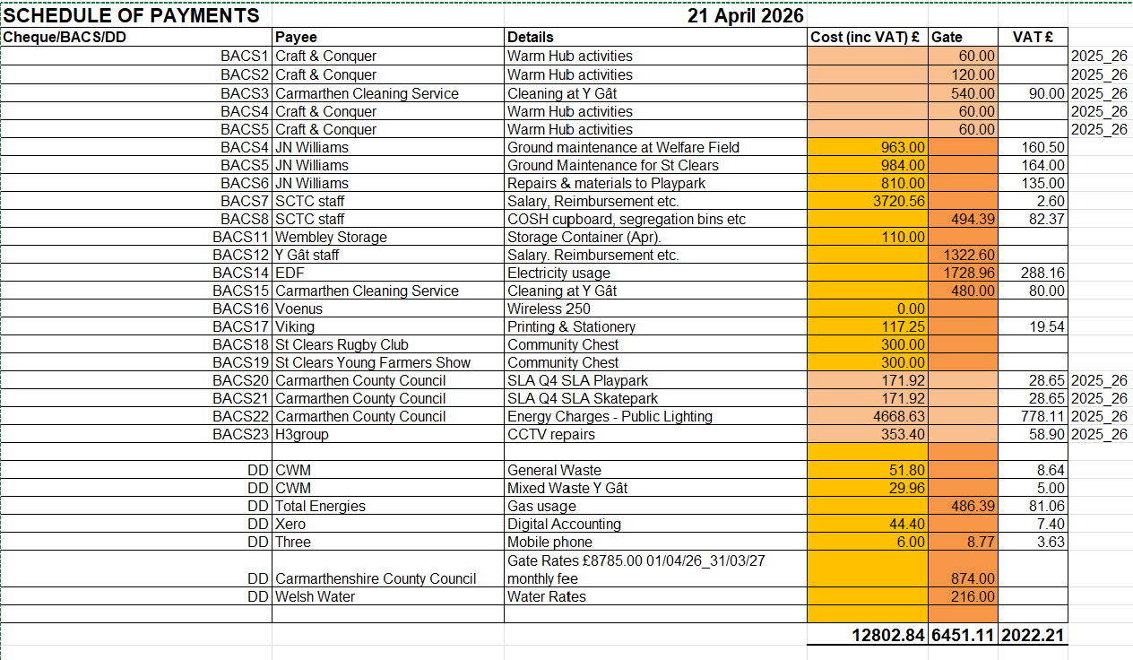
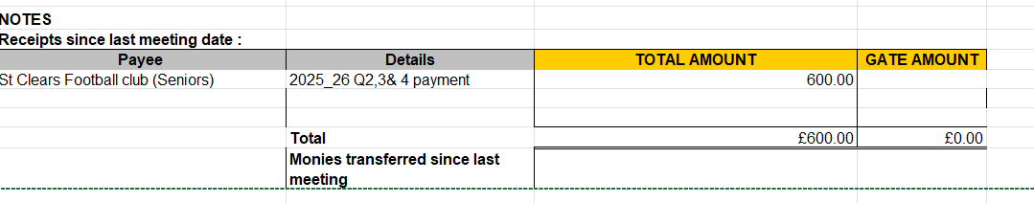

- To receive the year end budget monitoring report. The clerk presented Council with a draft profit & loss report and balance sheet for the financial year 2025_26 with a separate report for the Y Gât community asset. As the accounts for the community asset are included in the Town Council figures, this presents a disproportional view of the Council’s agreed budget expenditure. The clerk reminded Council that the agreed plan was for the facility to be managed as a community asset by a forum with support from TC and the accounts to be kept separately. A separate online platform would permit the facility manager to produce invoices and track all expenditure for the premises separate to that of the Town Council. The Council forum would then be able to regularly monitor expenditure deferred from Town Council expenses. Cllr BThornton proposed and Cllr IThomas-Wigley seconded the motion to purchase a Quickbooks account for Y Gât. Town Council budgeted £20,000 for the community asset and would pay this in 12 monthly instalments to the Y Gât account. The clerk would maintain responsibility for paying staff salary and reporting to HMRC.
RESOLVED to accept the year end budget monitoring report and purchase QuickBooks account for Y Gât.

- To approve schedule amendments for 2025_26.
Cllr RGEdwards proposed and Cllr IThomas-Wigley seconded the motion to approve the amendments to the 2025_26 schedules. RESOLVED to accept the amendments to the 2025_26 schedules.
Corrections to 2025_26 schedules
Date | Cheque/BACS/DD | Payee | Details | Cost £ (inc VAT) | Correct Amount | VAT
Apr-25 | DD | Welsh Water | Water Rates | Missing | 12.50
Jul-25 | BACS | Old Board School House Guest House | Mayor Making Event | Missing | 1800
Sep-25 | DD | Xero | Digital Platform | 39.60 | 44.4 | 7.40
Sep-25 | DD | Nest | Pension | 442.23 | 601.63
Oct-25 | DD | CCC | Rates | 189.90 | 190.00
Nov-25 | BACS | Rob Morgan & Sons | Christmas Trees | 1425.80 | 1425.60 | 237.60
Nov-25 | DD | CCC | Rates | 189.90 | 190.00
Mar 26 | DD | CCC | Two-year lift roaming SIM | Missing | 612.42 | 102.07
Mar 26 | DD | Three | Y Gât Mobile phone | 8.77 | 9.42 | 1.57
 |  |  | Totals | 2296.20 | 4273.55 | 246.57

- To confirm bank standing orders and regular payments. RESOLVED to approve the standing orders and regular payments listed below: -
DD | CWM Environment | Delittering General Waste
DD | CWM Environment | Y Gât paper/card, plastic & mixed waste
DD | Total Energies | Y Gât gas usage
DD | Xero | Digital platform
DD | Three | Mobile phone
DD | Three | Y Gât mobile phone
DD | Quickbooks | Y Gât digital platform
DD | Carmarthenshire County Council | Y Gât rates
DD | Welsh Water | Y Gât water rates
DD | Nest | SCTC staff pension
DD | Nest | Y Gât staff pension
RP | JNWilliams | Grounds Maintenance - SCTC
RP | JNWilliams | Grounds Maintenance – Welfare Field
DD | EDF | Y Gât electricity usage

- To approve bank signatories. Cllr Dr WEVJ Davies proposed and Cllr IThomas-Wigley seconded the motion to approve and continue with the current bank signatories. RESOLVED to approve and continue with the current bank signatories, Catherine Lloyd-Jenkins (Town Clerk), Graham Edwards (Cllr and authorising signatory), Jane Rees (Town Mayor).

- To review the asset register. Copies of the asset register were circulated and reviewed by members. Update with disposal of gazebo and old portable PA system and review of condition of outdoor adult exercise equipment. Cllr RGEdwards proposed and Cllr RDavies seconded the motion to approve the asset register and to contact the TC’s contractor with a view to relocating the adult exercise equipment on the grass verge near the skate park. RESOLVED to approve the asset register, to contact the Town Council’s contractor with a view to relocating the adult exercise equipment on the grass verge near the skate park, and to contact Carmarthenshire County Council regarding S106 funding for the play park.

- To consider Bancyfelin Play Park. The lease to the park was considered and any updates. The solicitor has noted key points for change, i.e. access for maintenance, insurance and is planning required to change land use. RESOLVED to contact Carmarthenshire County Council to request an update on the lease and planning requirements as soon as practicable, to expedite the exchange and signing of the lease, and to seek quotes for clearing the land in accordance with the agreed plan.

- To consider the benches (repair/replace) rolling programme. The Council considered the bench list for repair/replacement. RESOLVED to ask the Men’s
Shed to repair benches: -
No.2 - 3 & 4 Maesybryn - /// piglets.diagram.calibrate
No. 25 - Outside the Old Board School - ///scrum.emotional.fattest
and to ask the Council’s contractor to replace No. 5 the missing bench at Lon Hafren - ///became.chats.dialects with the new composite bench purchased which is currently outside Y Gât.
- To receive the Welfare Field sub-committee report. Consideration was deferred pending the sub-committee meeting. RESOLVED to resend the Oolong report to the subgroup and to request lease information from the Council’s solicitor.

- To consider the vacant seats on the Council. DEFERRED, no applications. to consider but further bilingual notice posted on Facebook, Website and Noticeboard.

- To receive reports from representatives on meeting of outside bodies, seminars etc. NONE.

- To receive the Town Mayor’s Report on civic events, engagements etc.
The Town Mayor attended the following: -
16th April – Bancyfelin Senior Citizens’
AGM
17th April – CCC Flood Defence drop in at Y Gât.

- Matters for the next agenda (exchange of information only).
Community Awards

There being no other business the chair closed the meeting at 9.30pm.

Appendices
Appendix i – broken glass on ground near skate park
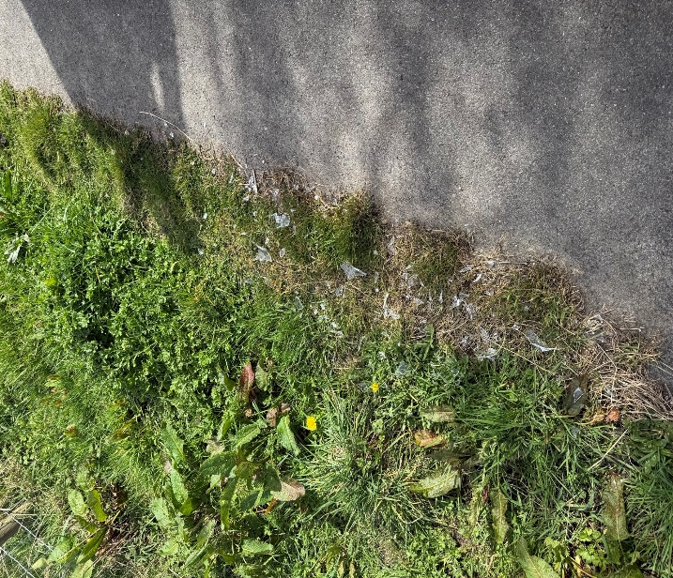

Appendix ii – Ira Taffy Jones commemorative plate on loan from Town Council and on display at the Porthcawl museum exhibition


